**Database:**

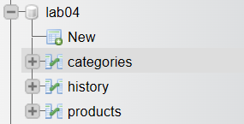

1. Categories Table:

2. Product Table:

3. History Table:

**Models:**

1. database.php:

1. category.php:

1. product.php:

**Code:**

1. layout_header.php:

1. layout_footer.php:

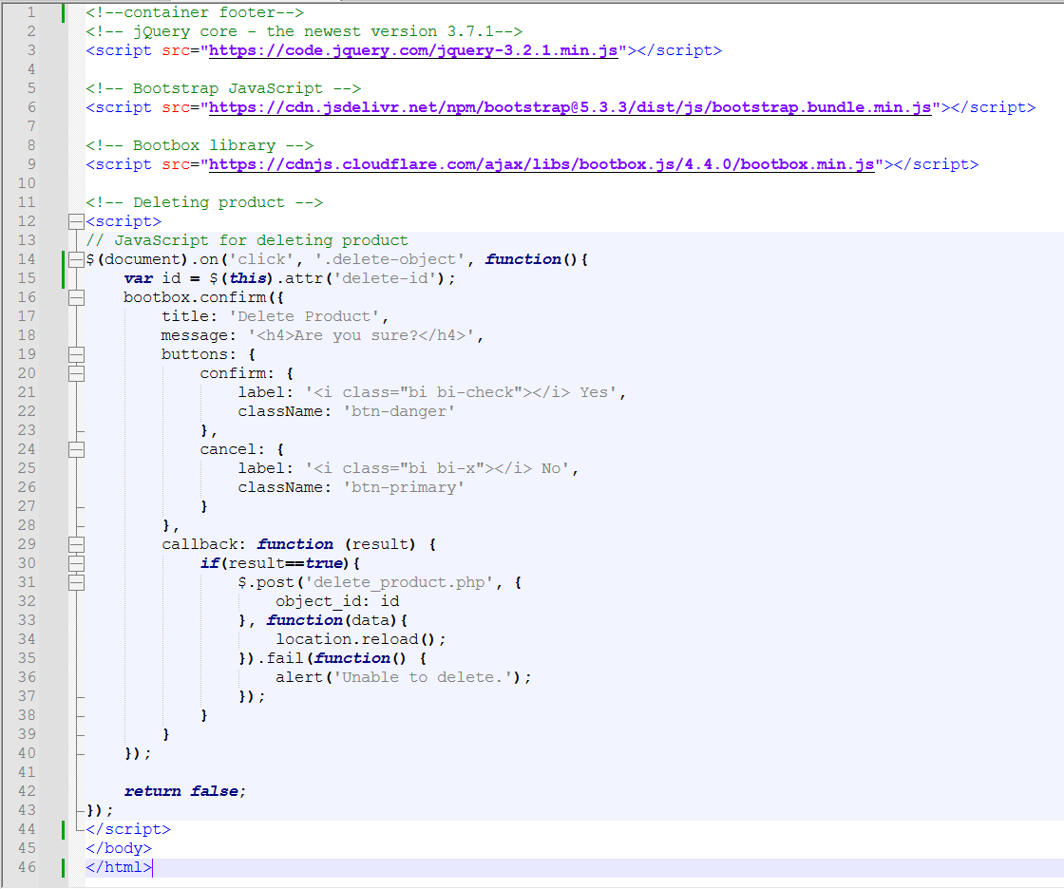

1. create_product.php:

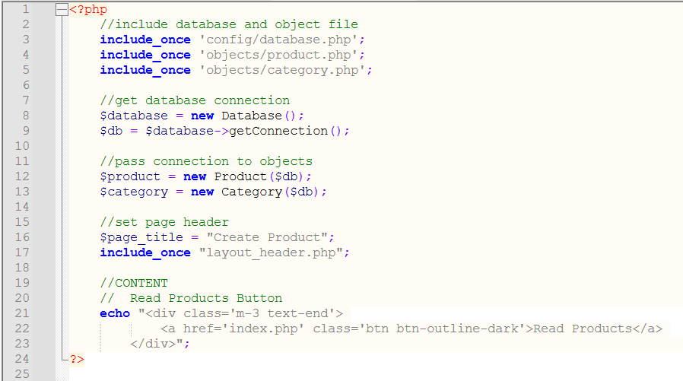

1. index.php:

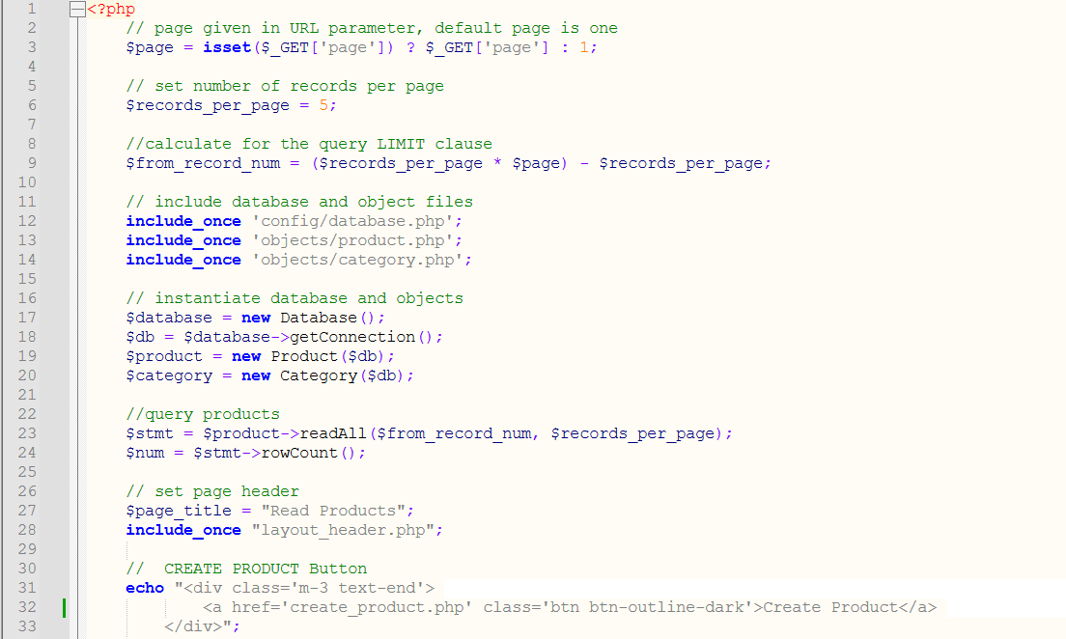

1. paging.php:

1. read_one.php:

1. update_product.php:

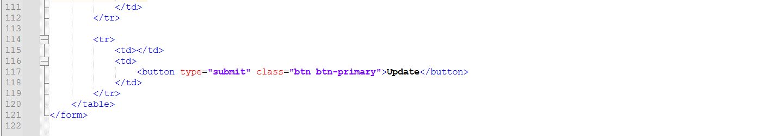

1. delete_product.php:

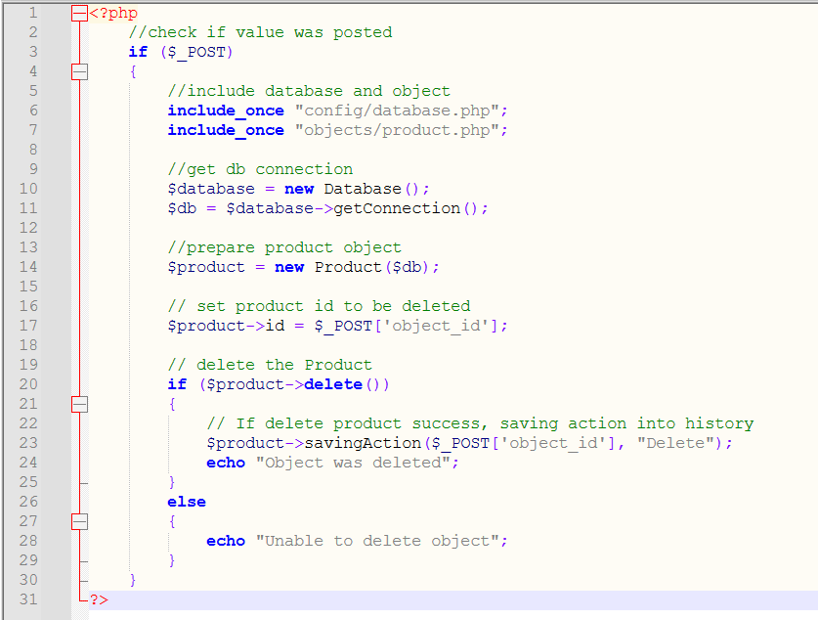

**Result:**

index.php:

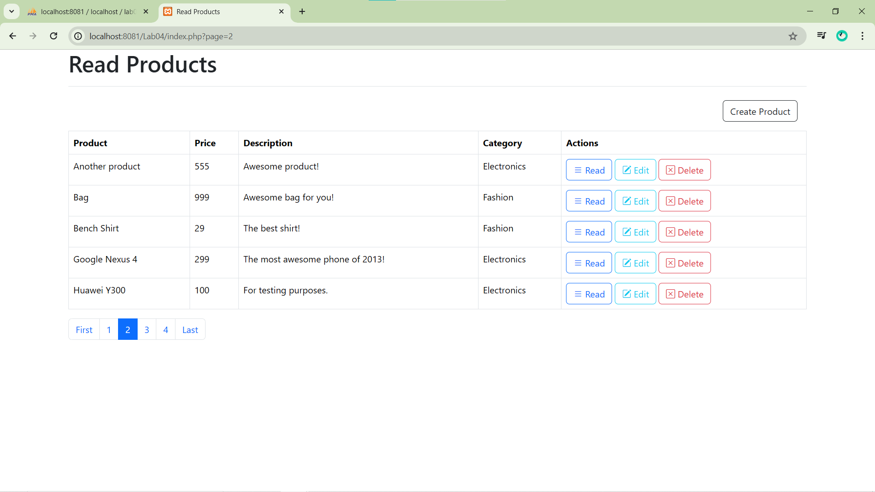

read_one.php:

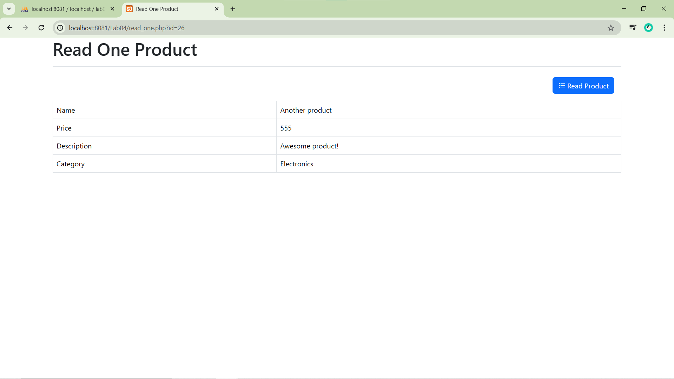

update_product.php:

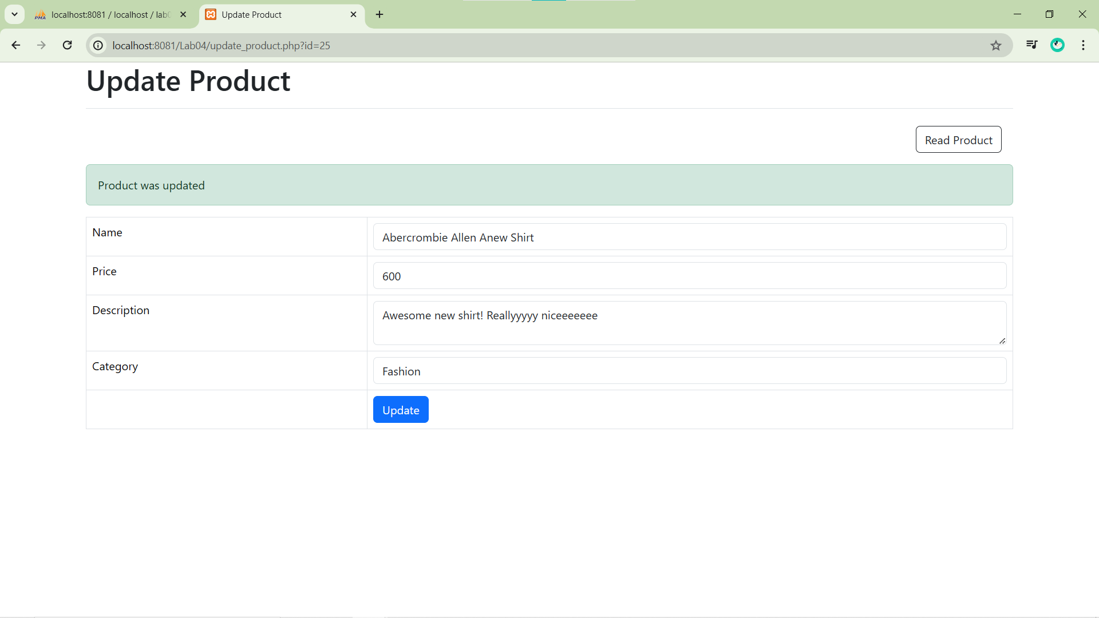

delete_product.php:

create_product.php:

**In database:**

Product Table:

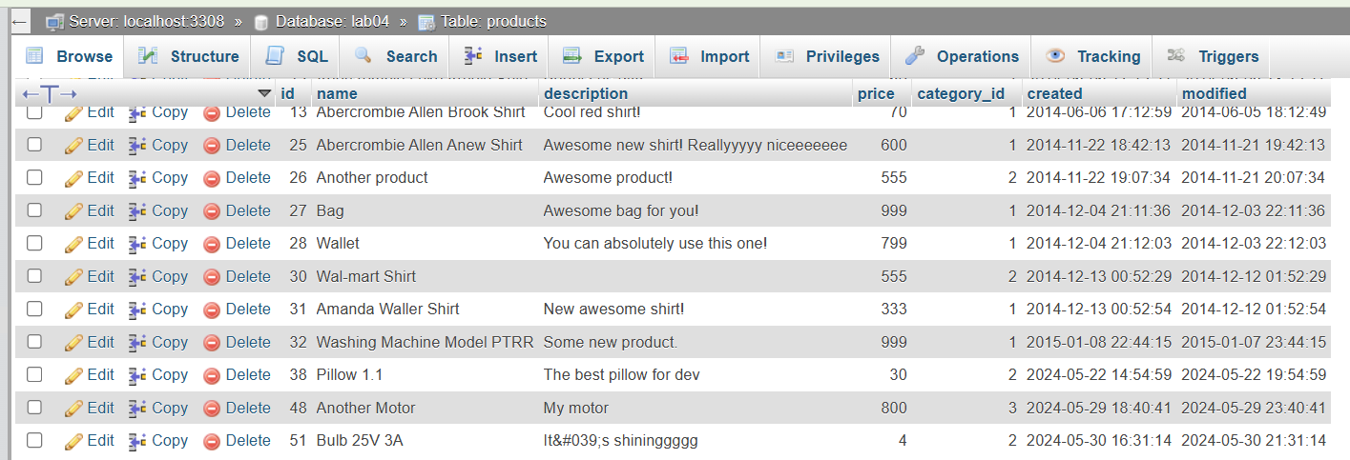

History Table:

